[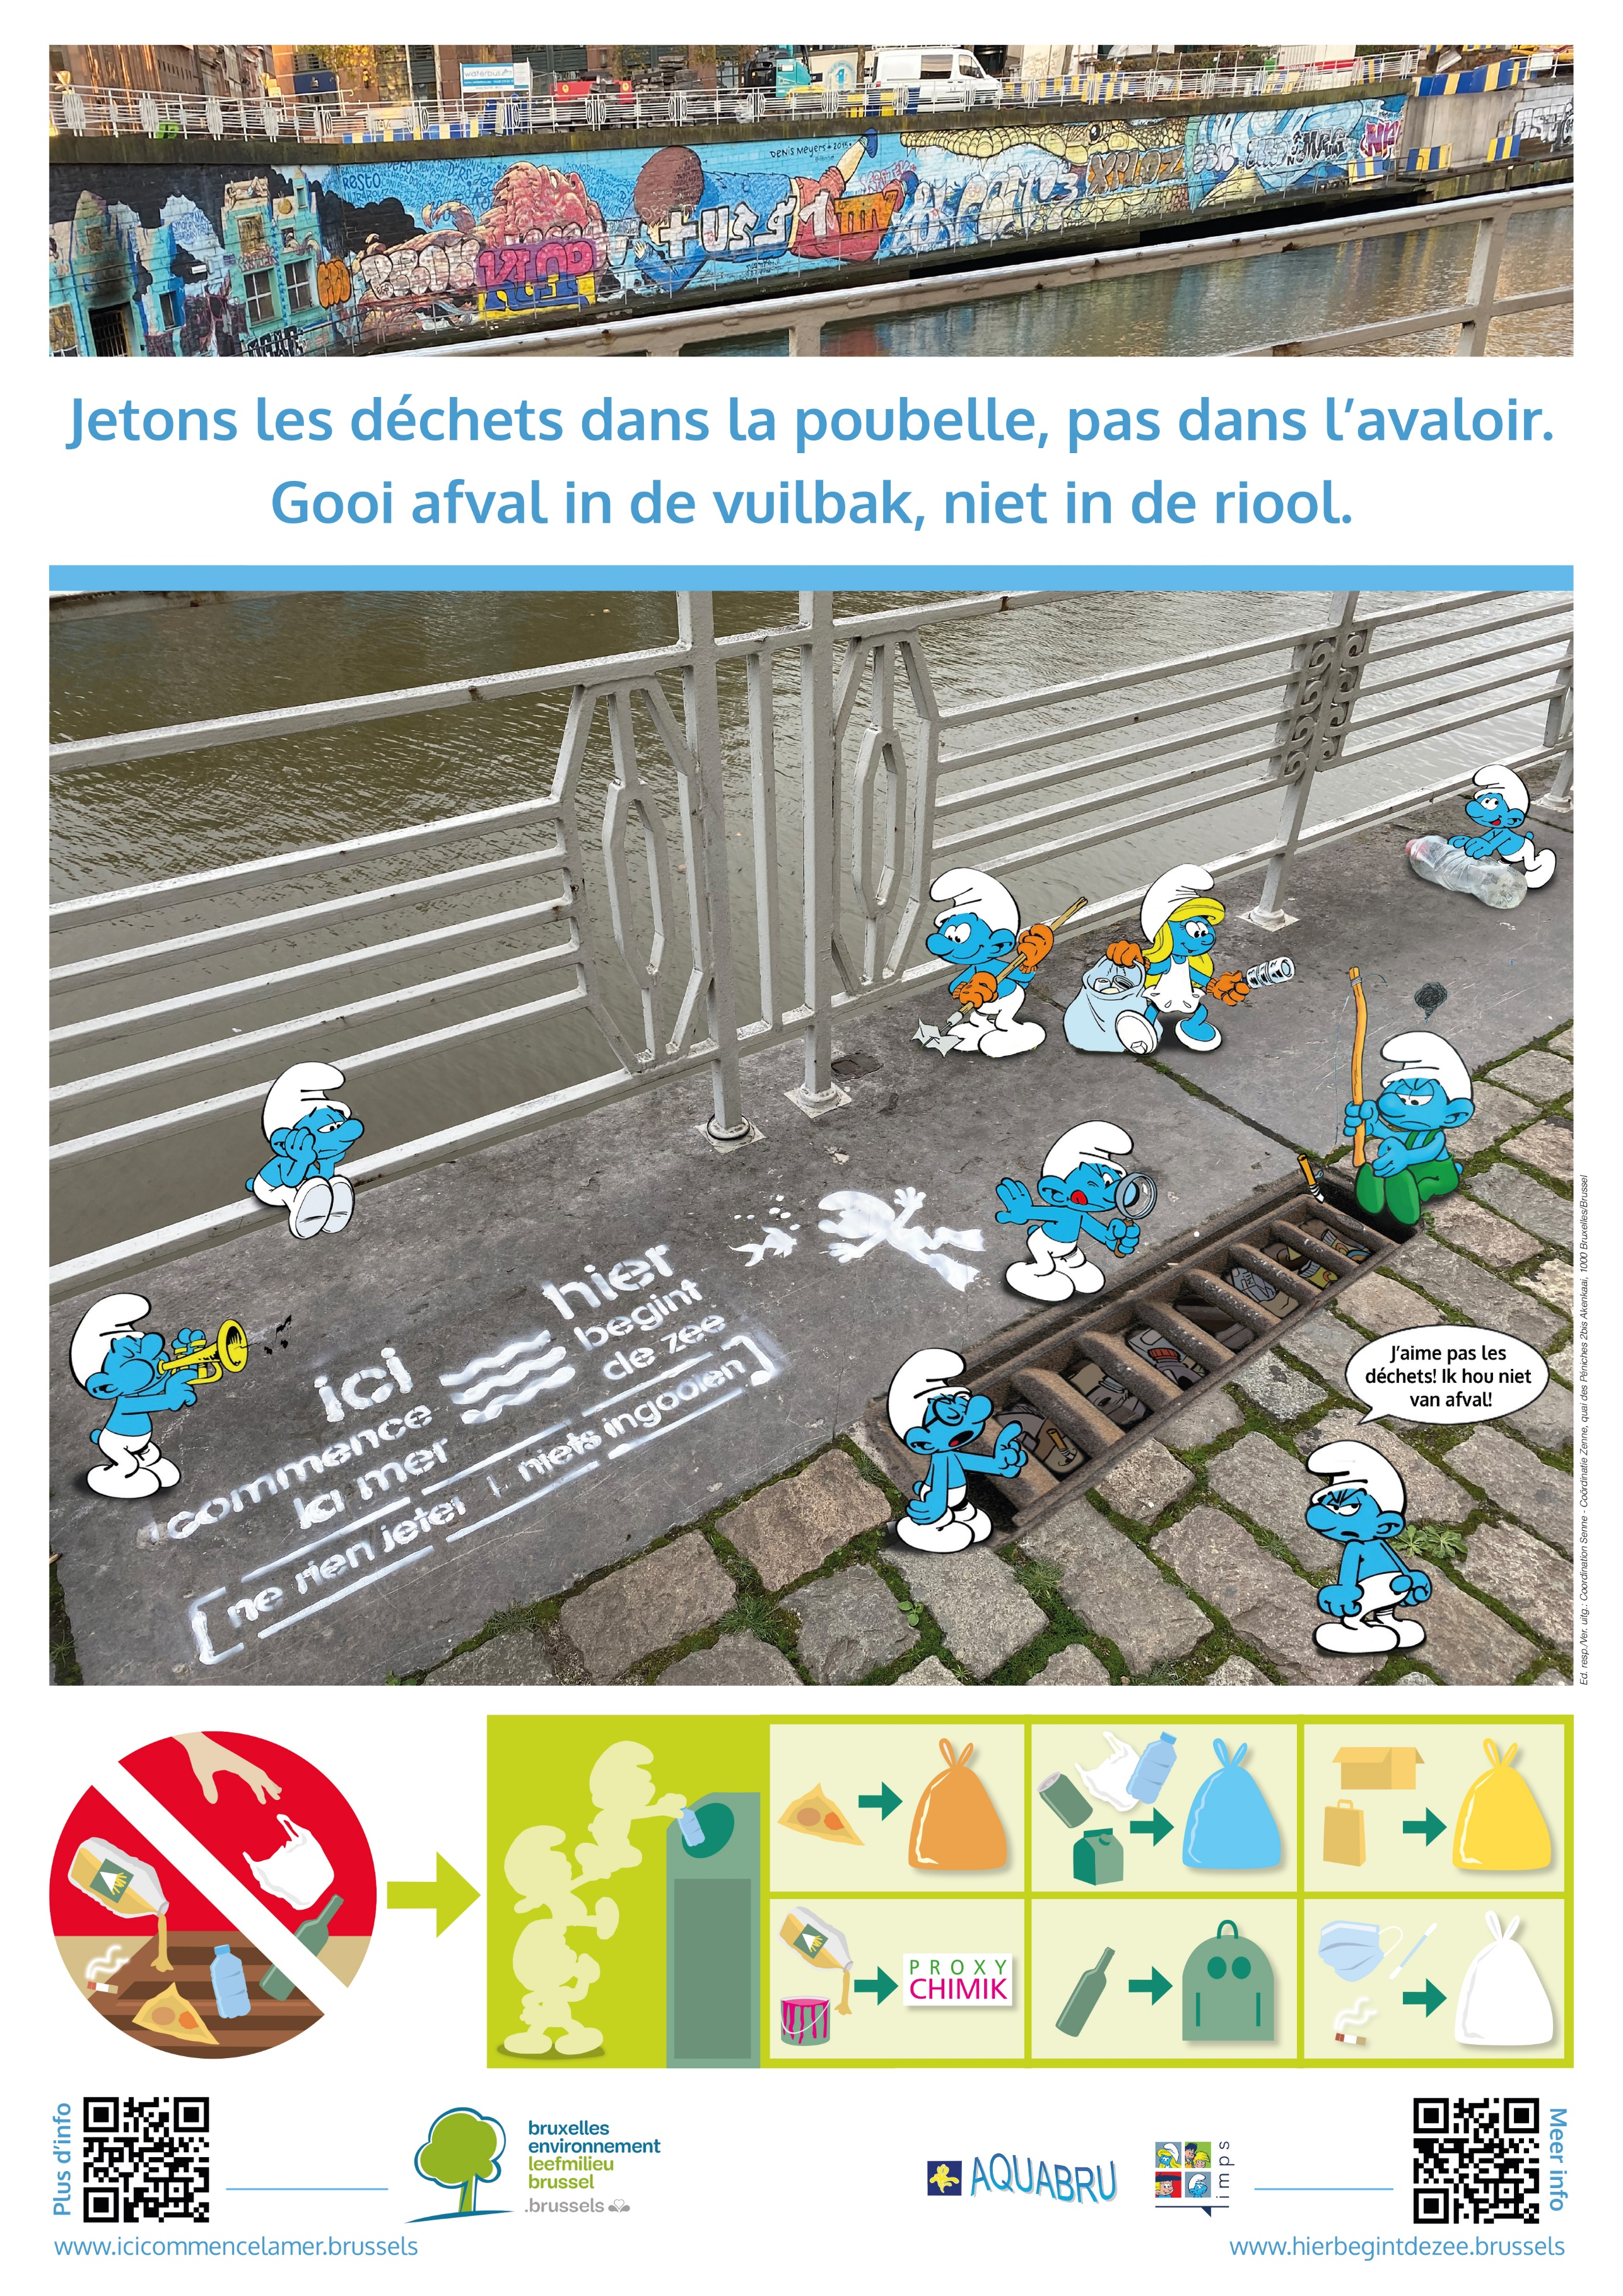](Affiche-A3_HBDZ_Picto_2023_PRINT_DEF.jpg)

